

**Config Manager – Imaging** User Guide

This guide will explain the process of imaging and reimaging a pc. It will go through the basics of creating a task sequence, advertising this sequence, finding the sequence on the pc and troubleshooting some basic problems.

**Contents:**

Creating/Editing The Task Sequence

Advertising The Task Sequence Advert

Deleting The Sequence

Using A Task Sequence On A Computer

Troubleshooting Problems

Searching For a PC

**Creating/Editing The Task Sequence**

This section will explain how to create a task sequence and how to edit the programs it installs.

To create a task sequence we will be duplicating the base sequence and making our changes to it instead of creating one from scratch.

Open config manager and go to the following area.

Site Database > Computer Management > Operating System Deployment > Task Sequences

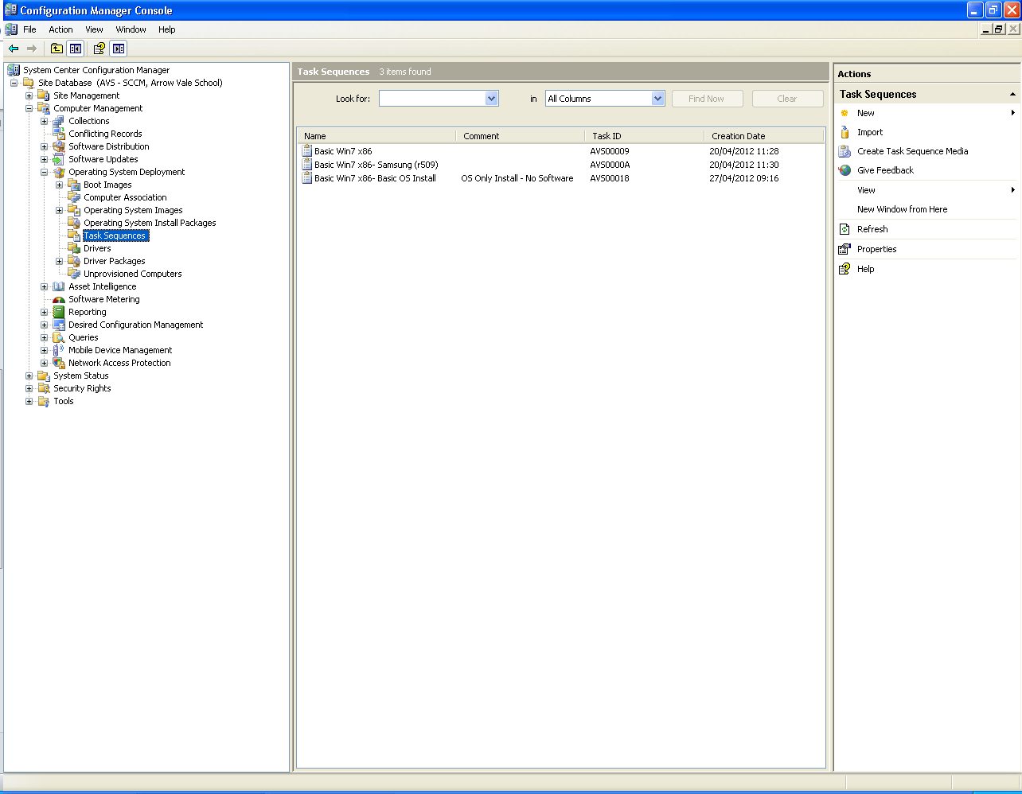

This area shows a list of all the current task sequences that are being used. To create a new one, right click on the ‘*Basic Win7 x86- Basic OF Install*’ and select duplicate.

This will have created a new task sequence which we can now edit to our needs.

Right click on the new sequence and select properties. In the name field type in the new name of the sequence keeping the ‘*Basic Win7 x86-*‘ part and delete the comments section. Click ok.

Now we will edit the sequence to add drivers and software to install while it is running.

Right click on the sequence and click on ‘*edit*’. This will bring up the following window.

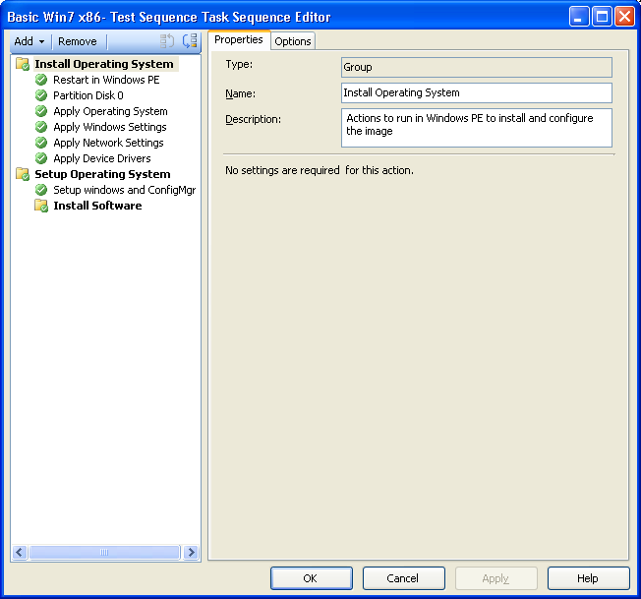

This is where we can change what the task sequence does. We can give it a different os to install, apply network settings, add drivers and install software as well as other tasks such as capturing a user state.

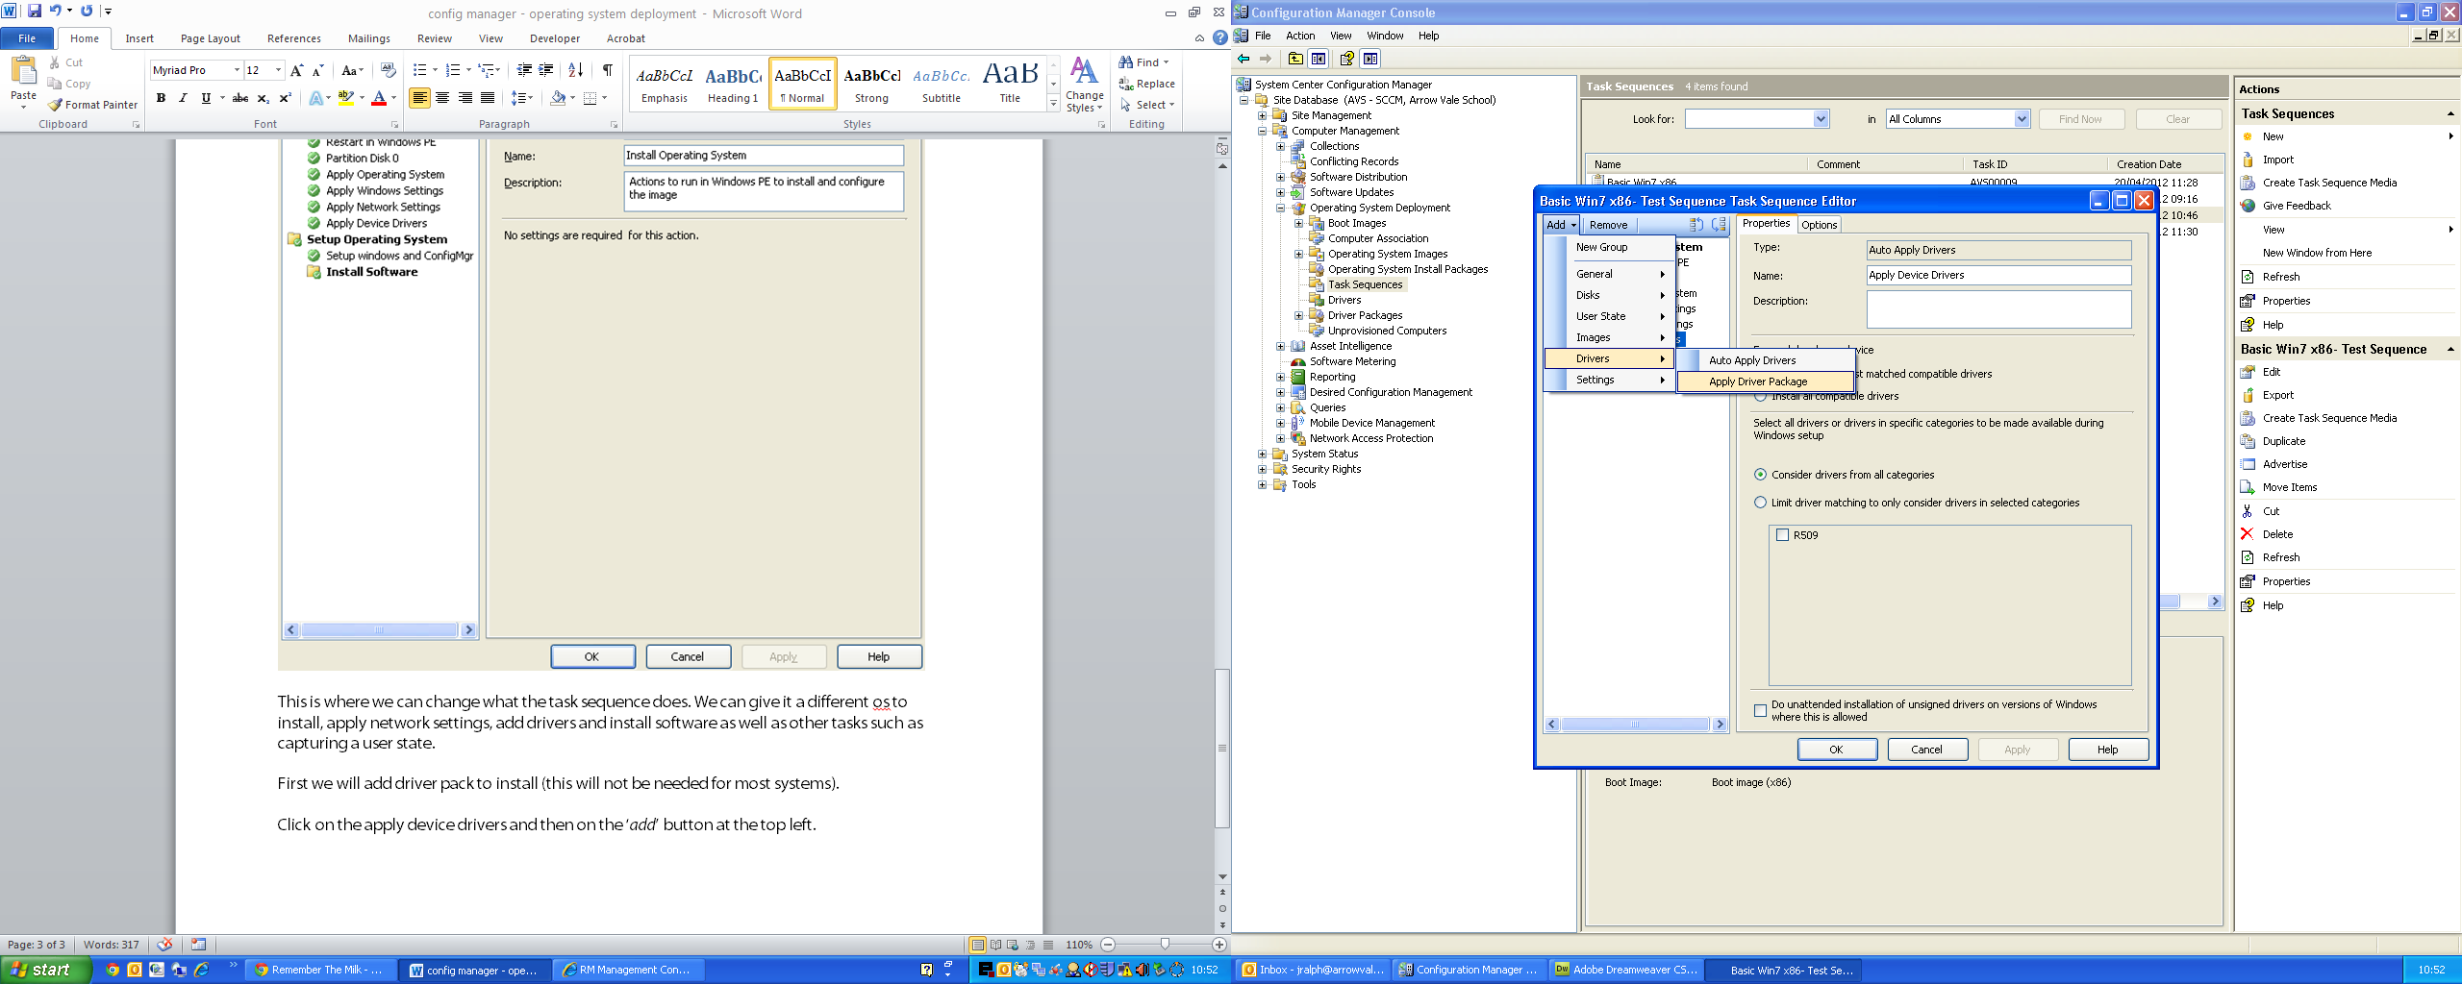

First we will add driver pack to install (this will not be needed for most systems).

Click on the apply device drivers and then on the ‘*add*’ button at the top left. Navigate to drivers and click on *‘Apply Driver Package*’. This will create a new install process below the selected process. You will notice that there is a red cross next to it, this means that it has not been configured and will not install.

If you click on this process, you will be able to give the task a name and browse for a driver pack to install. Another guide will cover creating driver packs.

Next we will be adding software install tasks. This is done the same way as the drivers but we want to make sure that the software tasks go into the ‘*Install Software*’ group. This will add an *‘Install Software’* task to the list with a red cross next to it.

Click on the *‘Install Software*’ task. Here you can add a name of the software that is being installed, a description and browse to the package. A good name for a software task is similar to the following. *Install Software “VideoLAN VLC Media Player Install”*.

Click on browse and you will be given a screen similar to the following.

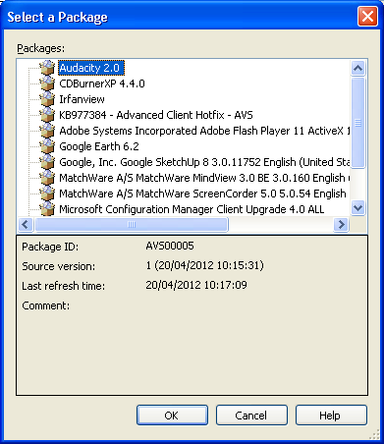

This screen will give a list of all of the packages you have on the server.

Select the package you want and click on ok. We will be adding CDBurner XP 4.4.0.

Once this is done, you will have the option just below the browse field to select a program to run. Most software will only have 1 program so this can usually be left at its default, if there are multiple options, make sure the silent install option is selected.

The last few stages can be repeated multiple times to install multiple drivers or software. Tasks can also be dragged up and down the list to make sure that things install in the correct order (dependencies).

**Advertising The Task Sequence**

The next stage is to advertise the task sequence to a collection or group of collections.

To advertise the sequence, right click on it and select advertise, this will give you the following window.

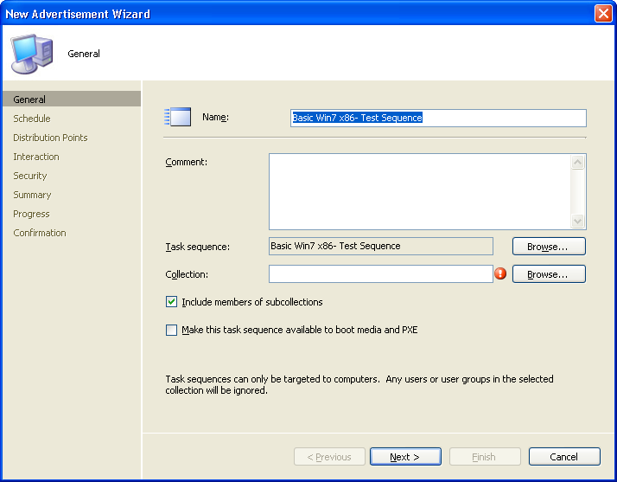

You will now need to select a collection to include. Click on the browse button next to the collection field. The window that pops up will display all of the collections that have been created.

The best place to advertise a collection is to *‘All Unknown Computers’*. This means that any computer that has not already been built on the network will be displayed here. If you are wanting to use the sequence to rebuild a pc, you may want to advertise the sequence to a sub-collection within *‘ARROWVALECUR.INTERNAL’*.

Once you have picked a collection you MUST make sure that the ‘*Make this task sequence available to boot media and PXE’* has been ticked or the computer will not pick up the package.

You can now click next on all of the following screens as no settings need to be altered.

**Deleting A Task Sequence Advert**

This next step will go through how to delete an advertisement. This can be useful and should be done if you want to remove a task sequence from being discovered by any computers.

To delete a task sequence advertisement you will want to navigate to the following area.

Site Database > Computer Management > Software Distribution > Advertisements

Deleting an advert is simple. Find the advert you wish to delete, right click and click delete.

When deleting an advertisement, changes are permanant and to add an advertisment back it will have to be recreated.

**Using A Task Sequence On A Computer**

This section will explain how to use an advertised sequence on a computer. There are unfortunatly no screenshots for the section!

These steps are the same for building an unknown pc or rebuilding one that already exists on the network. As long as the task sequence has been advertised to the pc, it should pick it up and install. If there are any errors, we will go through how to trouble shoot this in the next section.

Using a task sequence:

When booting up a computer you will want to make sure that network boot is enabled and is set to be the 1st boot device. If it is not set you will have to chose the network boot manually which can vary depending on the bios.

When booting from the network, the computer will contact the server and the PXE Service to check if any packages are available, once it has contacted the server you should be prompted to press F12 to boot from PXE. This will take you to the Windows PE screen where you will need to enter the password.

Once the password has been entered you will be given a list of boot sequences to run. Pick the one that corresponds to what you want installed on the computer and click next. If you are building an unknown pc, you will now have the option to name the computer. If you edit the value and input the name and click next to begin installing windows and software.

**Troubleshooting And Searching For Computers**

This section will explain some basics on troubleshooting any errors during the build process and how to search for computers using the information given.

To troubleshoot most problems you can use the System Status area. To view any PXE error messages you can navigate to the following area.

Site Database > System Status > Site Status > AVS > Component Status

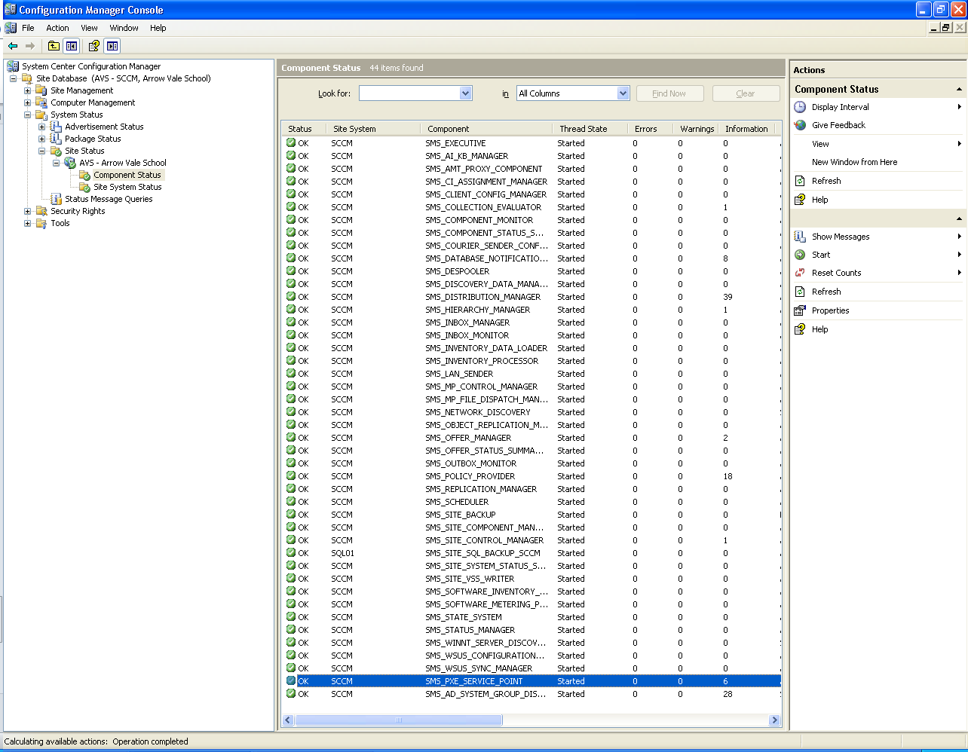

This area will show you the status of components running on the network as well as view any error messages. Find the SMS_PXE_SERVICE_POINT component and right click. Navigate to *show messages > all*.

This will show us all error messages and alerts from the PXE component. It will also give us the mac address of the computer that reported the problem. This lets us search for computers using our *MAC Finder* collection which will be explained next.

If you open the collections area, find and click on the *MAC Finder* collection and click properties.

Here you will want to navigate to the following area.

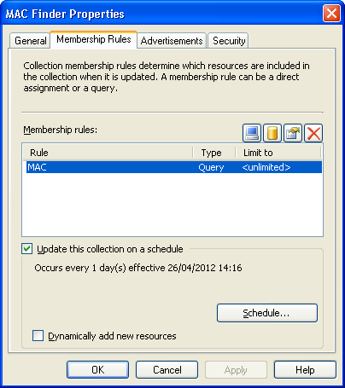Membership Rules > Edit Query > Edit Query Statement > Criteria > Edit Query

In this window, you can edit the query to search for all computers with the mac address. To search for a MAC address, type it into the *value* field and click ok to all of the windows.

If you now refresh the collection it will be displaying all computers with that MAC address only.